**Tutorail 8**

For making a pagination

Just add the **paginate(5).** in the controller

And in the view just add at the end of foreach() {{ $post->link()}}

/*

@foreach($post as $posts)

<div class="well">

<h3><a href="postall/{{$posts->id}}">{{$posts->title}}</a></h3>

<small>written by</small>

</div>

<hr>

@endforeach()

{{$post->links()}}

*/

//*

public function index1()

{

// $post = Post::all();

// $post = Post::orderBy('title', 'desc')->get();

//$post = DB::select('select * from users');

//$post = Post::orderBy('title', 'desc')->take(1)->get();

$post = Post::orderBy('title', 'desc')->paginate(3);

return view('posts.index1', ['post'=>$post]);

}

*//

**For loading js**

**<script src=”{{asset(‘js/abc.js’)}}”></script>**

**Forloading css**

**<link rel=”stylesheet” href=”{{asset(‘css/app.css’)}}”>**

**Removing public from the URL**

**1 enable rewrite module in apache**

**2under public cut the .htaccess and paste that in the root of the project**

**3 rename the server.php to the index.php**

//////

Routes

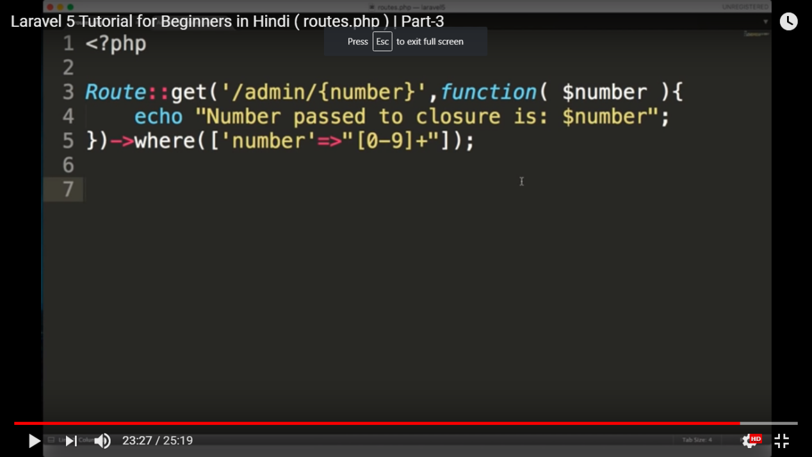

Named Route

Route::get('/admin1/{number}', function($number){

echo "number passed to the closure is : $number";

})->where(['number'=>"[0-9]+"]);

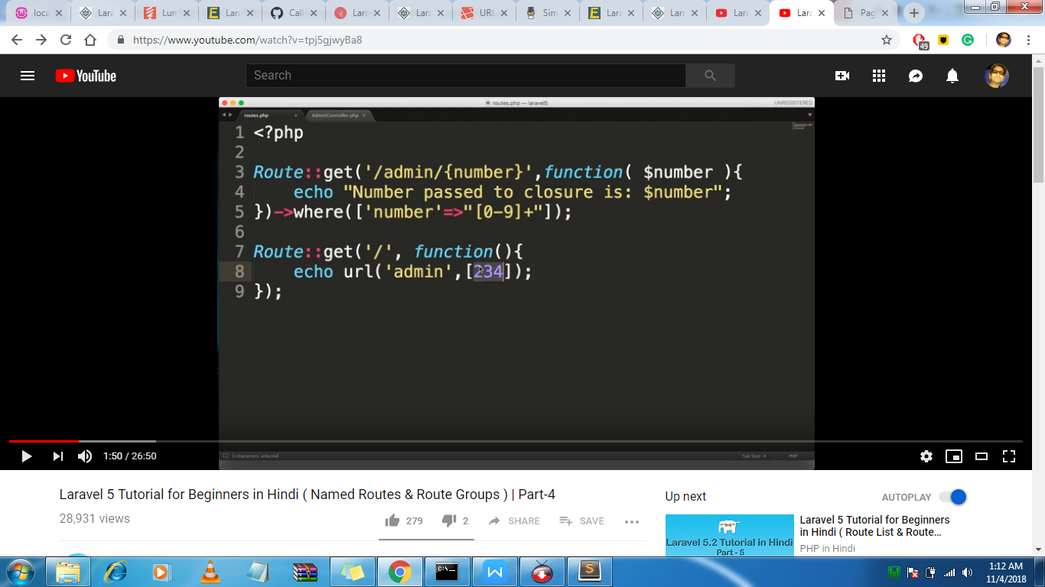

Named route

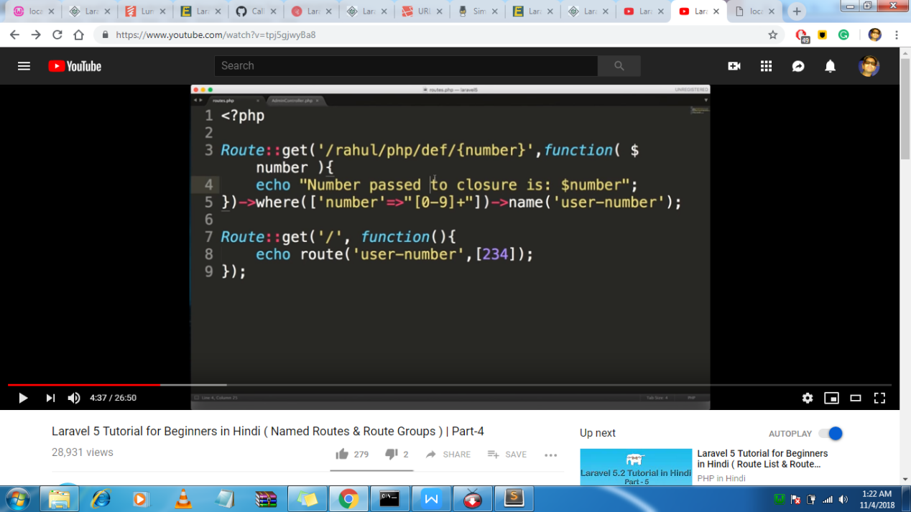

Route Group(first parametere array hoti aur 2nd parametere closure function)

Similar type ke route hote hai unpe koi cheze apply karne hai

Middleware ke through authentication hote hai

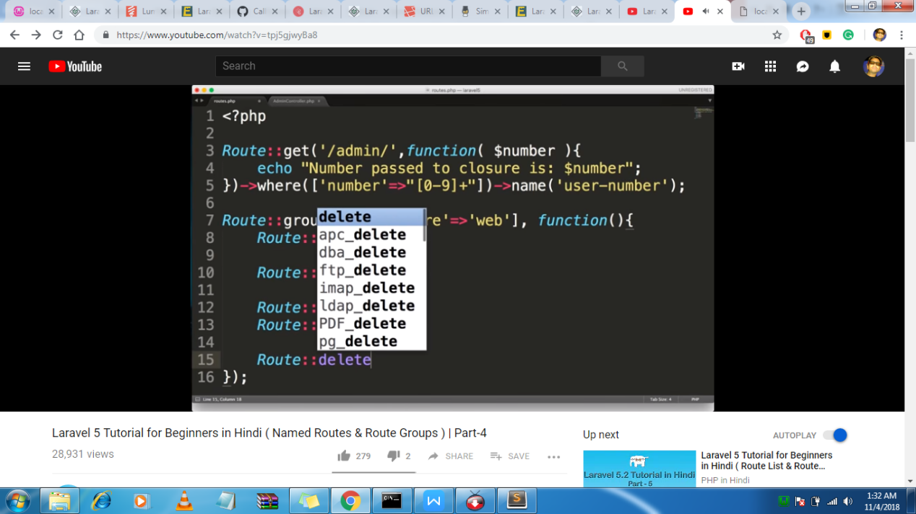

If we make dir under controller then we will use

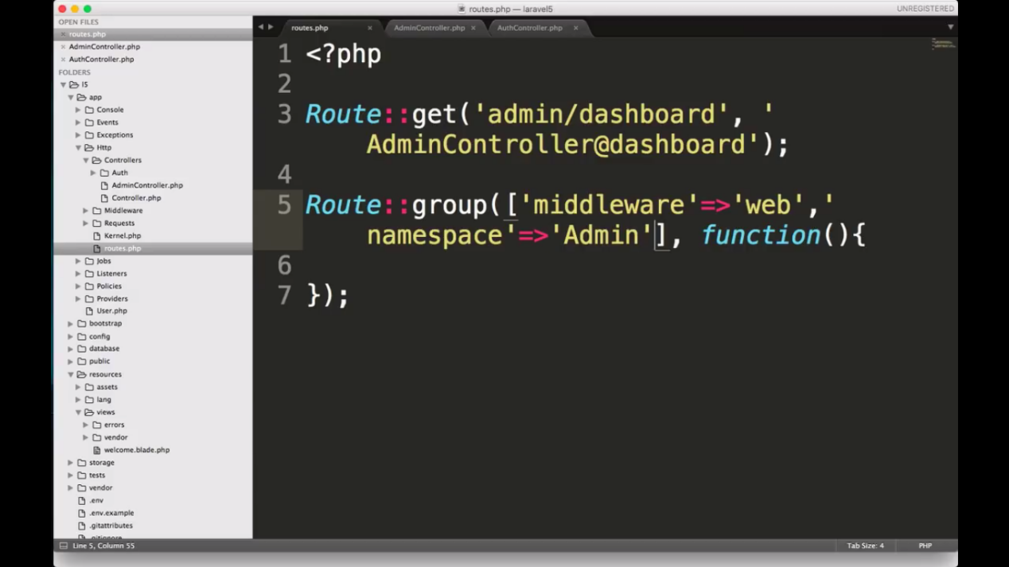

**Now here it will add a column to the posts table in database**

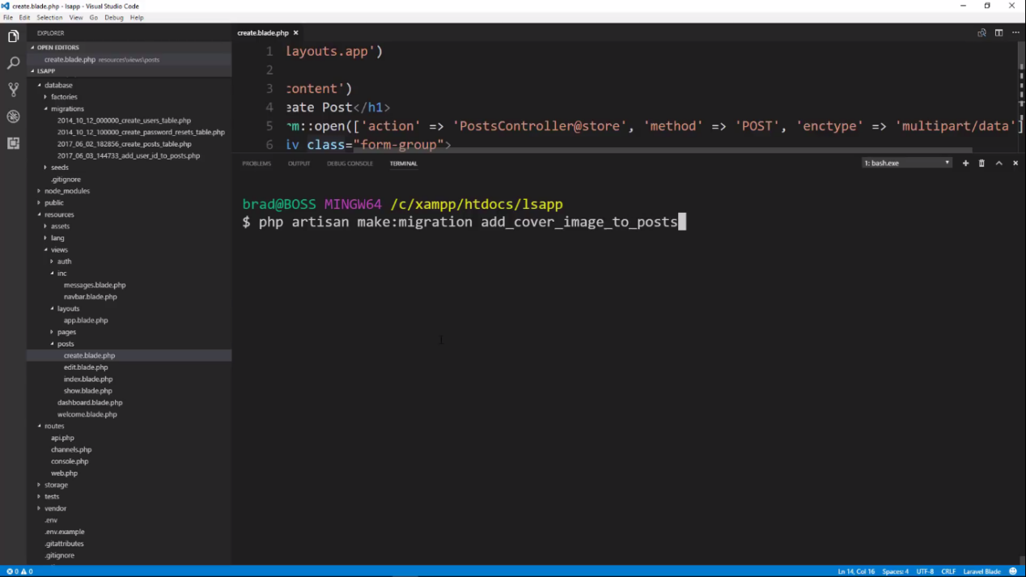

To enable auth just run the commnd

